

STUDENT HANDBOOK · WORKSHOP EDITION

Arduino + Processing
Five labs. One serial line. Measure the world, stream a number, draw it.
Erasmus+ KA210 · Project 2024-2-RS01-KA210-SCH-000271542 · High-school workshop


Partners: Cirkuliranje · Matematička gimnazija · Liceul Teoretic „Grigore Moisil” · Asociația One Source

How to use this handbook
This is the student edition of the Digital Challenge workshop tutorial. Each lab is a dossier: what you will learn, the words that matter, the circuit, one clean Arduino sketch, one clean Processing sketch, then exercises with hidden answers.
A lesson is four moves: Wire the plate. Print the serial line. Draw it in Processing. Prove it with two exercises and the quiz. Close the Arduino Serial Monitor before you start Processing — only one program can own the COM port.
The original file repeated every sketch twice, used HTML entities in Processing, and contradicted itself on the ohm-meter formula. This edition keeps the same five labs and the same photos, and writes one copy of each program.

Safety
USB power is enough for the Uno and one SG90 servo. If the board resets when the servo kicks, give the servo its own 5 V pack and join the grounds. No mains. No 12 V pumps in this workshop. Dry resistive soil probes after the lesson.

The serial contract
Every lab is the same handshake. Arduino prints one line and a newline at 9600 baud. Processing waits for that newline, trims it, and splits on commas. If you change the format on one side, the other side breaks. That is a protocol — two programs agreeing on bytes before they talk.
Lab | Arduino prints | Meaning
L01 Climate | 24.50,61.00 | temperature °C, humidity %
L02 Light | 731 | analogRead 0–1023
L03 Distance | 50.12 | centimetres
L03 Radar | 90,42.0 | angle, distance
L04 Ohm | 1500.0 or -1 | ohms, or OPEN
L05 Soil | 610 | raw ADC — calibrate yourself

Lab 01 — Climate station (DHT11)
The DHT11 is a digital sensor. It does not sit on A0. A chip on the package speaks a timed pulse train on a digital pin; a library decodes it. Relative humidity is “how full is the air’s water tank at this temperature?” — that is why a cold bottle sweats.
Accuracy is ±2 °C and ±5 % RH. Treat the numbers as trends, not laboratory truth.
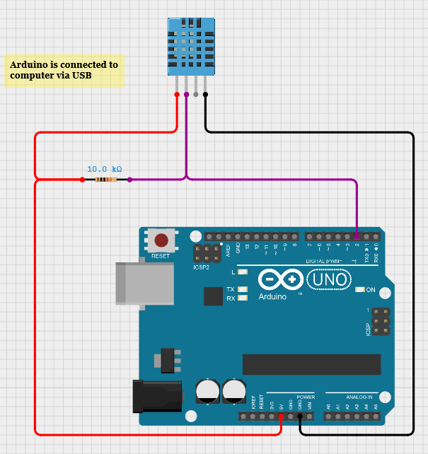
Figure — DHT11 to Arduino. The original drawing leaves DATA floating; follow the pin table: VCC→5V, GND→GND, DATA→D2. Add 10 kΩ between VCC and DATA on a bare 3-pin sensor.
Pin | Arduino | Note
VCC | 5V | Power
GND | GND | Common ground
DATA | D2 | 10 kΩ pull-up if the sensor is bare
DHT11_Serial.ino
#include "DHT.h"
#define DHTPIN 2
#define DHTTYPE DHT11
DHT dht(DHTPIN, DHTTYPE);
void setup() {
Serial.begin(9600);
dht.begin();
}
void loop() {
float humidity = dht.readHumidity();
float temperature = dht.readTemperature();
if (isnan(humidity) || isnan(temperature)) {
Serial.println("Failed to read from DHT sensor!");
return;
}
Serial.print(temperature);
Serial.print(",");
Serial.println(humidity);
delay(2000);
}

In Processing: import processing.serial.*, open Serial.list()[n] at 9600, bufferUntil newline, parse two floats in serialEvent, draw text plus two bars with map() and rect(). Alarm if temperature > 30 or humidity < 30.
Exercises in this lab: write the exact serial line; explain the pull-up; compute map(28,0,50,0,520); fix a NaN loop; log a CSV; design a 2-minute chart. Full prompts and solutions live on the website workbook.

Lab 02 — Light meter (LDR)
Arduino measures voltage, not resistance. An LDR alone is not a signal. Pair it with a 10 kΩ resistor: LDR to 5 V, 10 kΩ to GND, tap to A0. More light → R_LDR falls → V_A0 rises → analogRead climbs toward 1023.
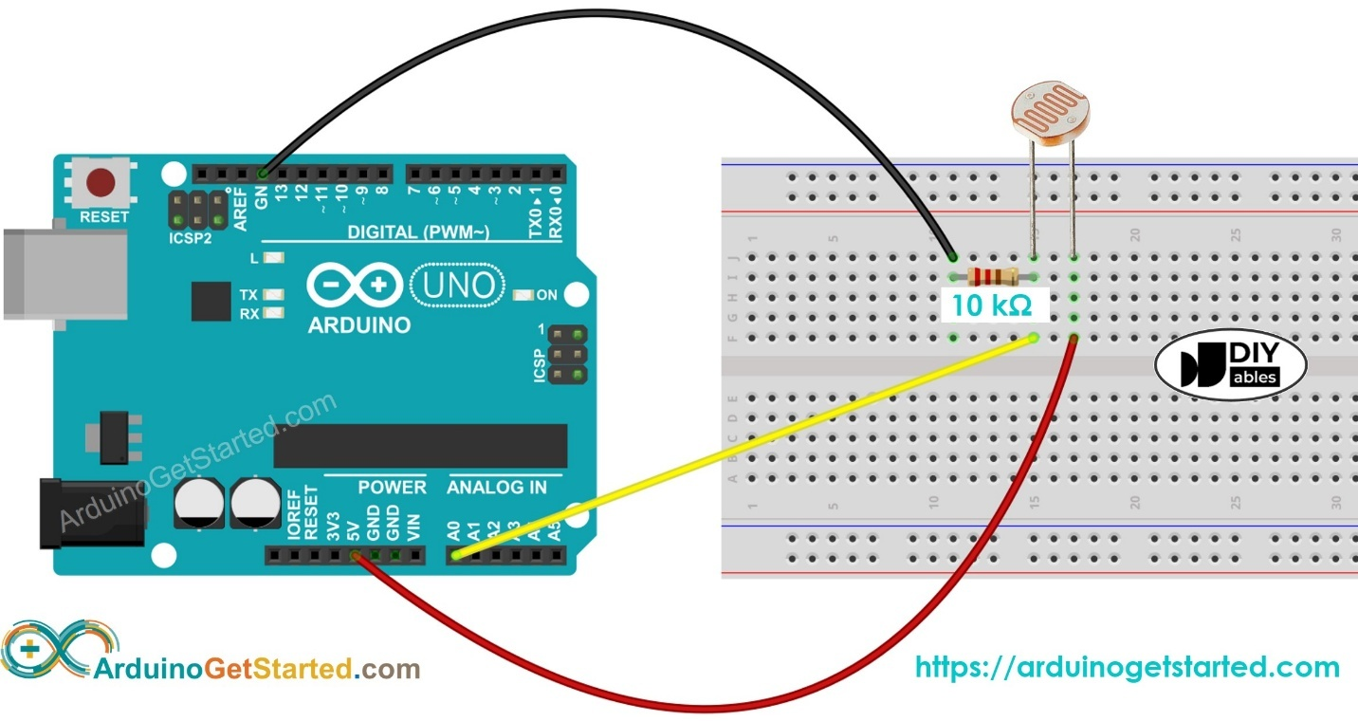
Figure — LDR + 10 kΩ voltage divider. The LDR has no polarity.
LDR_Serial.ino
const int sensorPin = A0;
void setup() { Serial.begin(9600); }
void loop() {
Serial.println(analogRead(sensorPin));
delay(200);
}

V_A0 = 5 V × R_fixed / (R_LDR + R_fixed). A good first fixed resistor is 10 kΩ — the same order of magnitude as a classroom LDR in indoor light. Calibrate dark-desk / room / window if you want a 0–100 % scale.

Lab 03 — Distance, servo and radar
The HC-SR04 clicks at ~40 kHz. Distance is half the trip because the sound went there and back: d (cm) = duration (µs) × 0.0343 / 2. Soft things absorb ultrasound. Always pass a timeout to pulseIn or a missing echo freezes the board for about a second.
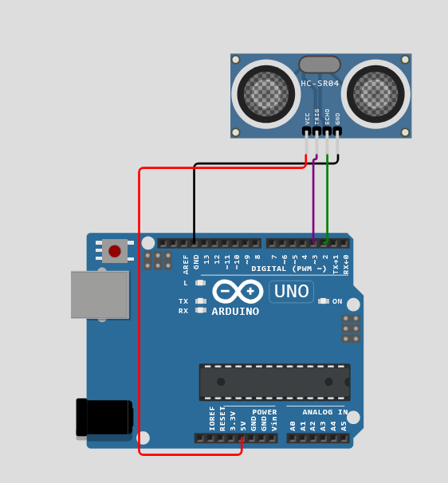
Figure — HC-SR04: VCC, TRIG→D3, ECHO→D2, GND.
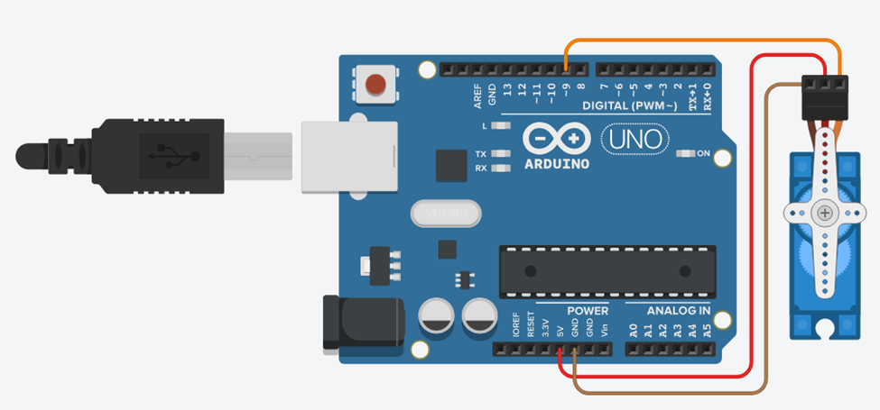
Figure — SG90: brown GND, red 5V, orange D9. One servo is usually fine from USB; if the Uno resets, use a separate 5 V pack and a common GND.
The original START/STOP sketch swept with two blocking for-loops, so STOP sat in the serial buffer until the horn finished 180°. Move one degree per loop() and read serial every step. Radar prints angle,distance and Processing plots x = r cos θ, y = r sin θ from the bottom centre of the window.

Lab 04 — Ohm meter
The original handbook wrote two opposite formulas. The Fritzing figure labels the unknown on the 5 V side and the known toward GND. Use that wiring:
R_x = R_known × (5 V / V_A0 − 1)
Accuracy is best when R_x ≈ R_known. A 1 MΩ unknown against a 1 kΩ reference puts a few millivolts on A0 — one ADC step is a huge error. If analogRead is ~0, send −1 so Processing prints OPEN instead of Infinity. Do not hold the leads in your fingers; skin is a parallel resistor.
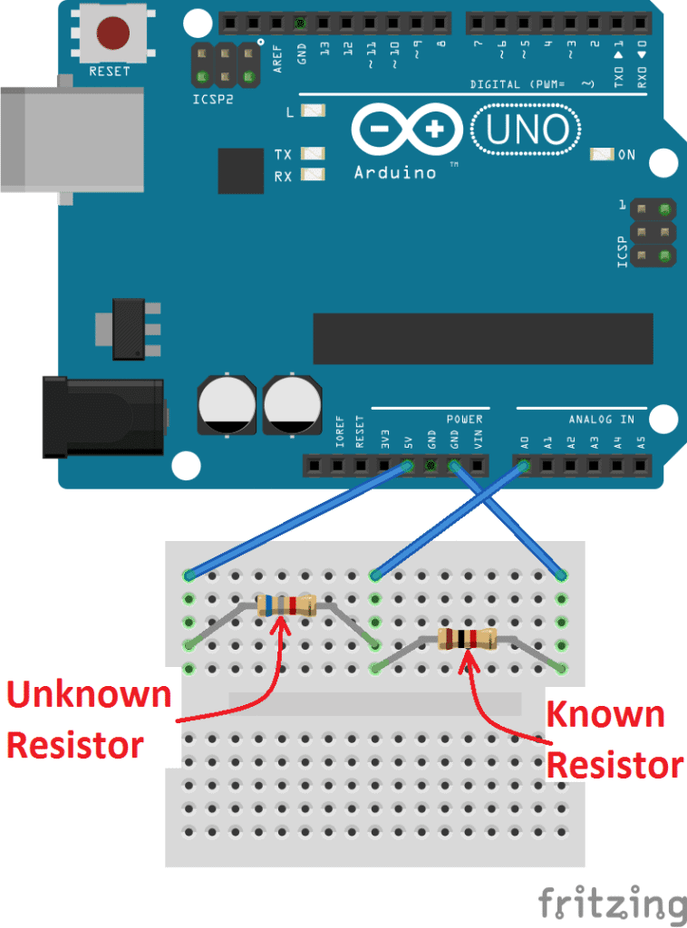
Figure — unknown on the 5 V side, known to GND, tap to A0.

Lab 05 — Soil moisture
Most classroom probes output a higher voltage in dry media and a lower voltage when wet. map(moisture, DRY, WET, 0, 100) reads backwards on purpose so a falling ADC still grows a “wetter” bar. Replace DRY and WET with averages from three cups — datasheets are a rumour until you measure your soil.
The original text says “capacitive v1.2”; the photo is a two-prong resistive fork. Both plug in the same way (VCC, GND, AOUT→A0). Dry resistive probes after the lesson — they rust.
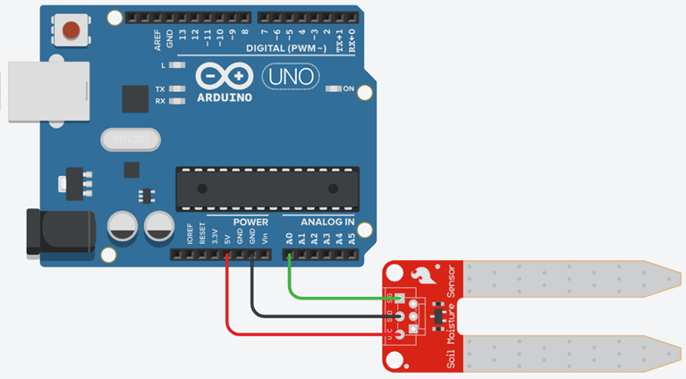
Figure — soil probe on 5 V, GND and A0.

Exercise bank (selected)
Work these on paper first. The website workbook has the full set with hints you can reveal.
ID | Prompt | Answer
L01-E1 Predict | Arduino prints 22.4 and 48. Write the exact serial characters, including the invisible ones. | 22.40,48.00 plus a newline. Number, comma, number, newline — no space.
L01-E2 Explain | Why does a bare 3-pin DHT11 need a 10 kΩ pull-up when a module often does not? | DATA is open-drain. The resistor holds the line HIGH. A module already has that resistor on the PCB.
L01-E3 Calculate | map(28, 0, 50, 0, 520) — how wide is the temperature bar? | 291.2 px.
L01-E4 Debug | A loop prints nan,nan every 200 ms. Name two bugs. | No isnan() guard; 200 ms is too fast for a DHT11. Wait 2 s and skip failed reads.
L02-E1 Predict | LDR to 5 V, 10 kΩ to GND. You cover the LDR. Does analogRead go up or down? | Down. More R_LDR drops more of the 5 V, so the tap voltage falls.
L02-E2 Calculate | R_LDR = 4 kΩ, R_fixed = 10 kΩ. Find V_A0 and analogRead. | 3.57 V → about 731.
L02-E3 Calculate | How many millivolts is one ADC step on a 10-bit 0–5 V Arduino? | 5 / 1023 ≈ 4.89 mV.
L03-E1 Calculate | pulseIn returns 2915 µs. Distance at 343 m/s? | ≈ 50.0 cm.
L03-E2 Calculate | Room is 10 °C (337.4 m/s), wall is 100 cm. What does a 343 m/s sketch print? | ≈ 101.7 cm (+1.7 %).
L03-E3 Debug | Why did the original START/STOP sweep ignore STOP for two seconds? | Blocking for-loops never read serial until the 0–180–0 cycle finished.
L04-E1 Calculate | Unknown on 5 V side, R_known = 1 kΩ, V_A0 = 2.0 V. Find R_x. | 1500 Ω.
L04-E2 Calculate | R_x = 2.2 kΩ, R_known = 1 kΩ. V_A0 and analogRead? | 1.563 V → about 320.
L04-E3 Explain | Why not measure 1 MΩ with a 1 kΩ reference? | V_A0 is ~5 mV — one ADC step. Error explodes. Match decades.
L05-E1 Predict | You dip a typical probe from dry mix into a wet cup. Does analogRead rise or fall? | It falls. map(v, DRY, WET, 0, 100) still grows the bar because DRY > WET.
L05-E2 Calculate | DRY = 880, WET = 340, reading = 610. Percent wet? | 50 %.
L05-E5 Design | Write hysteresis so a future pump does not chatter. | On if reading > 750; off if reading < 550; otherwise keep the last state.

Self-check — sample items
L01 The DHT11 talks on a digital pin as a timed pulse train, not as a voltage on A0.
L01 Check isnan() because a failed read returns Not-a-Number and wrecks the bars.
L02 More light makes V_A0 rise in this wiring (LDR on the 5 V side).
L03 We divide echo time by two because the sound went to the object and back.
L03 pulseIn without a timeout can sit for 1 s when there is no echo.
L04 Best accuracy when R_x ≈ R_known. Fingers on the leads make the reading drift.
L05 Wet soil usually makes analogRead smaller. Hysteresis uses two thresholds and a remembered state.

Teacher notes and errata
Where | Issue | Fix in this edition
L01 figure | DHT11 DATA not drawn to pin 2 | Pin table is the source of truth
L01 Processing | HTML entities; read inside draw() | serialEvent + bufferUntil newline
L03 servo | Blocking for-loops ignore STOP | One write per loop()
L03 pulseIn | No timeout | pulseIn(..., 30000)
L04 formula | Two opposite equations | Unknown on 5 V side: Rx = Rk×(Vin/V−1)
L05 sensor | Text says capacitive; figure is resistive | Same three wires; calibrate your probe
Suggested pacing: L01 and L02 on day one (2 × 45 min each). L03 needs a double period. L04 and L05 fit a second morning. Leave 20 minutes at the end of each lab for two exercises and the quiz.
Funded by the European Union. Views and opinions expressed are those of the author(s) only and do not necessarily reflect those of the European Union or EACEA.

